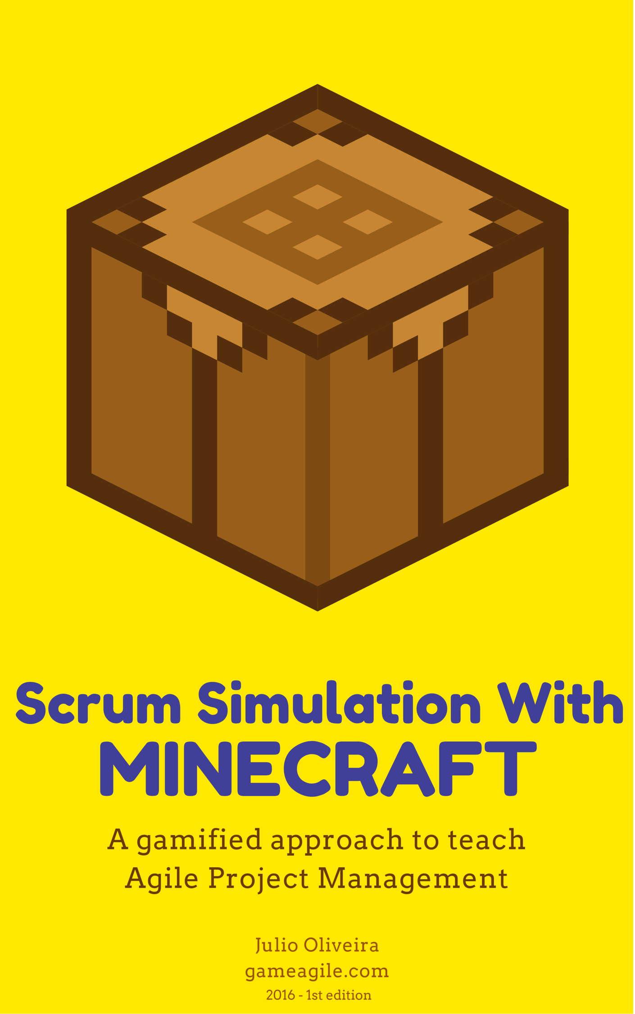

Index

Introduction 3

Why Simulate SCRUM? 3

Why Minecraft? 4

Creative Commons License - Attribution-ShareAlike 5

Activity Information 6

Timing 6

Materials and Resources 6

Group Size 6

Minecraft PC Editions 7

Minecraft (Standard) and Windows 10 Edition (Beta) 7

Dedicated Minecraft Server 7

Recommended Server Configs (server.properties) 8

Minecraft User License Cost 9

Minecraft Education Edition 10

Unique Features 10

Early Access 10

Eligibility 11

Minimum Hardware Specs 11

Roles 12

Product Owner (PO) 12

Scrum Masters 13

Scrum Teams 13

Instructor and Facilitators 14

Watch for Dysfunctions 15

Lack of Adherence on Agile Values & Principles 15

Scrum Dysfunctions / Scrum-But 16

Game Phases 17

Minecraft Bootcamp (2 hours) 17

Pre-Game (1 hour) 17

Product Backlog Board 17

User Stories 18

Estimation and Prioritization of the User Stories 18

Scrum Boards 19

Release Burndown Charts 19

Game (4 hours) 20

Sprint Planning (20 Minutes) 20

Sprinting (45 Minutes) 20

Sprint Review (10 Minutes) 21

Sprint Retrospective (5 Minutes) 21

Post-Game (1 hour) 21

Learning Points 23

Inspirations 23

About 24

# Introduction

Agile Project Management (APM) is an iterative process that focuses on customer value first, team interaction over tasks, and adapting to current business reality rather than following a prescriptive plan. It has a set of values, principles, and practices that assist project teams in coming to grips with such challenging environment (Highsmith, 2009).

APM is a rising trend nowadays, due our uncertain and turbulent world. Traditional approaches of project management have production-oriented project management processes, giving emphasis on complete early planning and requirements specification with minimal changes. The agile project management have exploration based processes, focused on rolling wave planning, stabilization of sets of requirements for each iteration, and experimental design with significant ongoing learning and change.

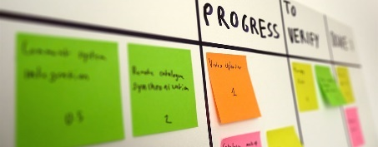Scrum is a APM framework created early in 90s by Ken Schwaber and Jeff Sutherland, about ten years prior to the creation of the Agile Manifesto - [www.agilemanifesto.org](http://www.agilemanifesto.org/). The agile manifesto, along with Schwaber's first book “Agile Software Development with Scrum” and the emergence of modern integrated development environments (IDEs), helped Scrum to be adopted massively in the early 2000s. The Scrum framework was originally oriented for software development projects, but it has proven to work well in a wide spectrum of industries. Nowadays Scrum is considered the most adopted agile project management framework around the world.

The values and practices of Scrum represent a big paradigm shift for professionals whom are familiar with traditional approaches for project management, where command-and-control-ism and micro-management are imperatives. This is a specific situation where the teaching of Scrum can take advantage of gamification to enhance student motivation and ease the transition to agile.

The term "gamification" means the usage of game thinking and game-based mechanics to engage people, motivate action, promote learning, and solve problems – in a wider context than the game itself. For instance, gamification can be used in education to enhance student comprehension, create awareness regarding environmental causes, increase customer satisfaction, simplify government services, and many other contexts. You can see some inspiring examples of gamification at [gameagile.com/media/gamification-examples/](http://gameagile.com/media/gamification-examples/).

## Why Simulate SCRUM?

As an agile instructor I've experienced several approaches and practices to ease the learning curve for the agile project management discipline. By definition, most of the APM frameworks have a very simple and plain documentation regarding how it works. This is intentional, as the framework itself must be very intuitive and help people to go directly to hands-on. There are two principal concerns:

* Any APM framework will become an empty vessel if there is no deep understanding of how agile values and principles should be put into practice;
* It is not enough to teach the APM framework through presentations and extensive documentation, students must feel the experience to grasp how it works in the real life;

In my experience, both concerns are best mitigated with a complete simulation of Scrum within the classroom. As this practice is almost a consensus among agile instructors, there are some great learning activities to simulate Scrum – created by the agile community. Most of these simulations of Scrum makes usage of LEGO/LEGO Mindstorms to provide a context where students are able to build a product - using the Scrum Framework to control and perform the work.

## Why Minecraft?

It is a fun game. Easy to use. Immersive. Cooperative.

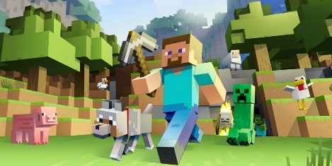Minecraft is a sandbox where there are almost no limits of what you can build: a space shuttle, a galleon, a modern city and even fictional places like King's Landing (from Game of Thrones). The platform is simple, functional, extensive and with a great potential for fun and learning - it is not by coincidence that Microsoft bought Mojang - the company who created Minecraft - for 2.5 BILLION on 2014. If you are not familiar with it, I do recommend to give it a try - [minecraft.net](https://minecraft.net/).

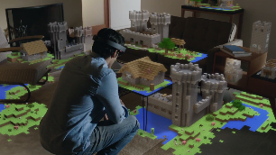We can consider Minecraft as LEGO with no limits and infinite possibilities, where students are tumbling down the rabbit hole - in an immersive environment. It gives a perfect context to simulate Scrum. And to think that this experience will soon be even more immersive by making usage of gadgets like Microsoft Hololens - [www.microsoft.com/microsoft-hololens/en-us](https://www.microsoft.com/microsoft-hololens/en-us).

All these characteristics will result in an epic experience for students, where they will be proud not only because they will learn, but also because of what they will be able to build inside the game. In the end of my first experience with the Scrum simulation using Minecraft, students were so happy regarding what they were able to build that they asked me to provide a copy of their Minecraft world. A memory of a great achievement, after all, being able to deliver an epic project using a revolutionary agile framework in a gamified context is a unique experience. If you want more information about the results of my first experience, please visit the post-exercise survey results at [gameagile.com/surveys/post-exercise-survey-for-agile-students-results](http://gameagile.com/surveys/post-exercise-survey-for-agile-students-results/).

So be it. We learn better when we are intrinsically motivated.

## Creative Commons License - Attribution-ShareAlike

A Creative Commons (CC) license is a public copyright license that enable the free distribution of an otherwise copyrighted work. A CC license is used when an author wants to give people the right to share, use, and build upon a work that they have created.

This gamified learning activity is licensed under the Attribution-ShareAlike license (CC BY-SA), which lets others remix, tweak, and build upon this work even for commercial purposes, as long as they give appropriate credit and license their new creations under the identical terms. All new works based on this one must carry the same license, so any derivatives will also allow commercial use. For more information, see [creativecommons.org/licenses/by-sa/4.0](https://creativecommons.org/licenses/by-sa/4.0/).

# Activity Information

## Timing

8 hours (full day), divided in:

* Minecraft Bootcamp – 2 hours;
* Pre-Game – 1 hour;
* Game – 4 hours;
* Post-Game – 1 hour;

## Materials and Resources

* 3 sheets of cardstock per group;
* 1 set of colored pens per group;
* 1 pack of post-it notes per group;
* 1 plastic ruler per group;
* 1 roll of adhesive tape;
* 1 notebook/desktop with mouse for the instructor (4 GB of RAM recommended);
* 1 notebook/desktop with mouse per student (2 GB of RAM recommended);
* Minecraft user licenses;
* Minecraft server (if not using the Minecraft Education Edition);

## Group Size

4 – 6 students per group. Maximum of 4 groups, otherwise it will be very difficult to keep a productive enviroment.

# Minecraft PC Editions

## Minecraft (Standard) and Windows 10 Edition (Beta)

When playing standard Minecraft, you can play a singleplayer or multiplayer game. As this learning activity demands a multiplayer game, there are only three options to put all students in the same world:

* LAN (local area network)
  + You play by opening your game, on your own PC, to the local area network (LAN). In this way others, who are also connected to that network, will be able access your game;
  + Very easy to configure;
  + Limited to 8 simultaneous players;
  + No additional cost;
* Dedicated Server
  + You play on a dedicated server by locating and connecting to the IP address of a multiplayer server;
  + Difficult to configure for novice players;
  + No limit of simultaneous players;
  + No additional cost if you host the server in your own PC or infrastructure. Otherwise you will have to pay the hosting;
* Minecraft Realms
  + You play using a multiplayer service developed by Microsoft/Mojang;
  + Easy to configure;
  + Limited to 10 simultaneous players;
  + US$ 7,99 per user / per month;

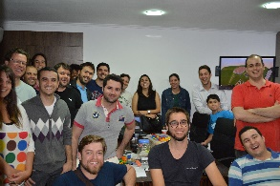Regularly my Scrum classes have about 12 to 18 students, in this case the viable option is to setup a Dedicated Server. If your Scrum classes have fewer than 10 students, consider the other options (LAN & Minecraft Realms). You can find more info about multiplayer options at [help.mojang.com/customer/en/portal/articles/429052-how-do-i-play-multiplayer-](https://help.mojang.com/customer/en/portal/articles/429052-how-do-i-play-multiplayer-) .

### Dedicated Minecraft Server

You can host a Dedicated Minecraft Server on your own machine, in this case playing in your LAN. If you like this idea, please read this basic step-by-step guide at [wikihow.com/Host-a-Minecraft-Server](http://www.wikihow.com/Host-a-Minecraft-Server).

My preferred choice is to use a Minecraft hosting service provider. There are a plenty of companies offering inexpensive and “ready-to-use” plans for Minecraft servers, the ones that I like the most are:

<https://www.minecraft-hosting.pro/>

<https://www.minecraft-worlds.com/>

<https://mcprohosting.com/>

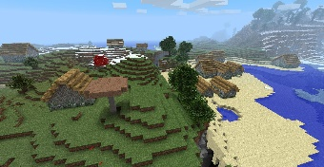You can obtain a great list of Minecraft hosting service providers at [enjin.com/game-hosts](http://www.enjin.com/game-hosts). By using such service, the configuration of the server will be much easier... specially for people whom are not familiar with Minecraft.

Regardless of your choices, your LAN must be very stable and with a good throughput to support multiplayer. My first option is to use a wired network. If you plan to use a wireless network (WLAN), I do recommend to buy a router compatible with the 802.11ac standard with support for several connected devices. Do not forget to make available a good internet connection, especially if your Minecraft Server is on the internet.

You will not like to have your students impacted due unstable connection, this can mess up the whole educational experience.

### Recommended Server Configs (server.properties)

Here are the configuration options (server.properties) that I do recommend for your Minecraft server, to facilitate the Scrum Simulation. You should avoid distractions (npcs, animals, monsters), guarantee a proper terrain (flat) and provide unlimited resources (creative mode) for your students during the Scrum Simulation to keep the focus. For a better description on every property, please visit [minecraft.gamepedia.com/Server.properties](http://minecraft.gamepedia.com/Server.properties). The properties marked in red are the most critical:

op-permission-level=4

allow-nether=false

level-name=Scrum World

enable-query=false

allow-flight=false

announce-player-achievements=true

server-port=25565

max-world-size=29999984

level-type=flat

enable-rcon=false

level-seed=

force-gamemode=true

server-ip=

network-compression-threshold=256

max-build-height=256

spawn-npcs=false

white-list=false

spawn-animals=false

hardcore=false

snooper-enabled=false

resource-pack-sha1=

online-mode=true

resource-pack=

pvp=false

difficulty=0

enable-command-block=false

gamemode=1

player-idle-timeout=0

max-players=30

max-tick-time=60000

spawn-monsters=false

generate-structures=false

view-distance=10

motd=Scrum Minecraft Server

### Minecraft User License Cost

Minecraft is not a free game, you have to pay for every user (student) that will participate in your Scrum Simulation. The standard user license costs US$ 26.95, you must multiply this value for the quantity of students that you will have in your class to see the total investment. Please visit [minecraft.net/pt-br/store/](https://minecraft.net/pt-br/store/) to understand the licensing model.

The good news is that Microsoft is releasing the Minecraft Educational Edition this year (2016). The current beta is free although, with a future license cost of US$ 5 per student – more than 4X cheaper than the standard Minecraft license cost. See more info below the next section.

## Minecraft Education Edition

Minecraft: Education Edition is an educational version of Minecraft specifically designed for classroom use. It is being developed by Mojang AB and Microsoft Studios and contain features that will make Minecraft easy to use in a classroom setting.

The full game is planned to be fully released in Fall 2016, although the beta test has started on June and it is planned to end on September. Any eligible institution (see eligibility requirements below) can join the early access during the beta test with no cost. After the beta test, the full game will cost $5 per user per year, much cheaper than the standard Minecraft user license.

The following video has a brief explanation about Minecraft Education Edition, including experiences from educators: [www.youtube.com/watch?v=hl9ZQiektJE](https://www.youtube.com/watch?v=hl9ZQiektJE). For more info, please visit [education.minecraft.net](http://education.minecraft.net/).

### Unique Features

* Secure student login IDs with individual avatars to personalize learning experiences;
* Camera and Student Portfolio, where students can take photos of their projects in Minecraft: Education Edition to demonstrate learning and progress;
* Classroom management features including Peaceful world settings to ensure students stay on task;
* A collection of specialized blocks to enhance teaching and learning, including new signs to share information and give direction;
* Enhanced multi-player, where up to 30 students can collaborate and work together on a set of learning activities without a separate server;
* Tutorial experience for first-time Minecraft educators;

The feature that I really loved is the support for up to 30 students in the multi-player mode, without a server. This makes the setup of Minecraft much easier.

### Early Access

Minecraft: Education Edition early access is available this summer for educators and students to try the game for free. Early access will end in September 2016. All users of Minecraft: Education Edition needs an Office 365 Education account to play the game.

### Eligibility

Minecraft: Education Edition will be available for purchase by schools, libraries, museums, and participants in nationally recognized home-school organizations. The early access respects the same criteria. For those unsure if their institution qualifies, the specific details on eligibility are:

* An eligible educator must be a full-time or part-time faculty or staff member at an academic institution and have a school-specific email address provided by the school (for example, contoso.edu) that can receive external email.
* An eligible district or school must be a qualified education user, defined as an accredited institution organized and operated exclusively for the purpose of teaching its enrolled students.
* An eligible public library must provide general library services without charge to all residents of a given community, district, or region.
* An eligible public museum must be an agency or institution organized on a permanent basis for essentially education or aesthetic purposes, and utilize a professional staff to exhibit tangible objects to the public on a regular basis.
* Finally, an eligible home-school program must provide K-12 education to a student or students with written proof that it either belongs to a nationally-recognized home-schooling organization or is expressly recognized by a local school district as an acceptable alternative to an accredited or state-recognized/approved educational institution.

## Minimum Hardware Specs

If your device meets the minimum hardware specs for Windows 10, it will run Minecraft: Education Edition:

* Processor: 1 gigahertz (GHz) or faster processor or SoC
* RAM: 1 gigabyte (GB) for 32-bit or 2 GB for 64-bit
* Hard disk space: 16 GB for 32-bit OS 20 GB for 64-bit OS
* Graphics card: DirectX 9 or later with WDDM 1.0 driver
* Display: 800x600

# Roles

This Scrum Simulation takes place after a well-executed instruction regarding the whole Scrum Framework. It is the final piece of the Scrum Training, where all students already have a basic understanding regarding Scrum. This simulation also assumes that all students have a primary comprehension of the agile values and principles, stated within the agile manifesto.

## Product Owner (PO)

The Product Owner, as in the real life, plays a foundational role in this learning activity. He is responsible for:

* Create, improve and prioritize of the product backlog during the Grooming;
* Elucidate any doubts of the Scrum Teams, regarding the product backlog, during the Grooming and Sprints;
* Negotiate the product backlog with the Scrum Teams during the Sprint Planning;
* Provide feedback for the Scrum Teams during the Sprints;
* Evaluate the result of the work (products) of the Scrum Teams inside Minecraft during the Sprint Review;
* Accept or reject of the result of the work (products) of the Scrum Teams during the Sprint Review;
* Keep the product backlog up to date and prioritized;

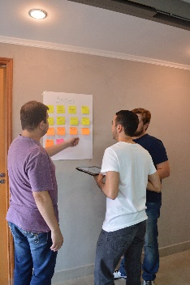The instructor may play this role, although I do prefer to invite a special guest to become the PO. By special I mean a relevant person at the company (if the training is in-company) or at the training center, someone that will bring a special touch and focus to the PO role.

Independently of who will be the PO, I do recommend that he/she to do some homework/preparation a couple of days before the training. The main thing to take care of is the selection of the project that the Scrum Teams will build and the list of user stories.

There are several options like houses, monuments, pixel art, vehicles, gardens and many others. You may search for inspirational examples of Minecraft buildings at [planetminecraft.com/resources/projects/land-structure](http://www.planetminecraft.com/resources/projects/land-structure/) and [minecraft-schematics.com/sizes](http://www.minecraft-schematics.com/sizes/). Keep in your mind that the Scrum Teams will have only few hours to build everything, choose something that is feasible and that will make everybody proud of.

My first experience with the Scrum Simulation happened with an MBA class, from a Federal University in Brazil. The University was planning to create an Innovation Center, cultivating this dream and looking for investors at that time. So I suggested to let them build the Innovation Center as the project for the Scrum simulation. A dream inside the dream. I asked the person who was responsible for MBA management to become the PO and, for my happiness, he accepted the invitation and played very well the role.

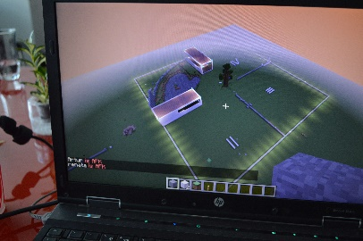Let the PO be free to choose the project scope. He/She may even provide some examples and inspirations (from those sites above) to help the Scrum Teams to understand the project nature. It’s almost certain that the PO has no previous experience, and this is excellent. If this is not the case, please ask him to play the "inexperienced" PO. This will create situations where the Scrum Masters and Scrum Teams will have to deal with conflict, putting them outside the comfort zone and stimulating a real-word happening.

## Scrum Masters

The Scrum Master will be someone from inside each group, elected by the group participants. The number of Scrum Masters will vary according to the number of groups (Scrum Teams) or, in other words, from 1 to 4 Scrum Masters. The Scrum Master are responsible for:

* Coach his Scrum Team regarding the Scrum framework (values / principles / roles, ceremonies / artifacts);
* Help his Scrum Team to remove blocks/impediments;
* Act as a facilitator in the Scrum ceremonies;
* Protect his Scrum Team from external interruptions;
* Advise his Scrum Team on conflict situations;
* Work with the Instructor, Product Owner and Scrum Team to guarantee a sustainable and productive rhythm for the Scrum Simulation;
* Continuously improve the Scrum Process;
* Keep the Release Burndown graphs up to date;

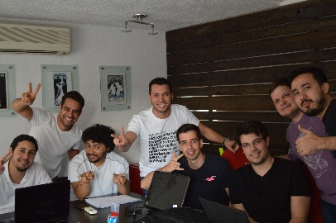As the Scrum Masters will have no experience on playing their roles, they will not be aware of all aspects of the Scrum Framework. This is expected and welcome, since the Instructor role is to observe the gaps in all roles - aiming to provide a constructive feedback during the debriefing in the Post-Game phase.

I suggest to not let Scrum Masters enter in the Minecraft world, as they will not build. They can see what the Scrum Teams are doing by looking into their screens. Scrum Masters must practice the holistic view of everything inside Scrum, including people behaviors, roles being played and rules of the ceremonies.

## Scrum Teams

The Scrum Teams represent the groups of students that will work together to deliver the project. This implies in a good teamwork and collaboration between team members and also with other teams, as they will work together to implement the product backlog. The Scrum Teams are responsible for:

* Verify if the stories within the product backlog are comprehensive and with enough details (concept of ready) during the Grooming;
* Negotiate the division of the product backlog among all Scrum Teams;
* Negotiate the product backlog with the PO during the Sprint Planning;
* Plan the execution of the work during the Sprint Planning;
* Execute the work inside Minecraft during the Sprints;
* Participate in the Scrum ceremonies during the Sprints;
* Prepare and show the work completed (concept of done) inside Minecraft during the Sprint Review;
* Verify what went well and what need to be improved for the next Sprint during the Sprint Retrospective;
* Keep the Scrum Board up to date;

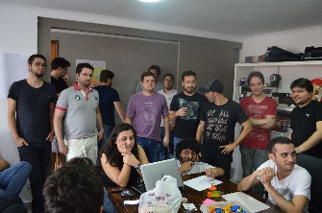It is very important to let the teams practice self-organization, even if this means a lot of confusion in the first Sprints. The Scrum Teams have to experience the continuous improvement inside of Scrum, and the responsibility that comes with the autonomy. The Scrum Master elected by the team will play an important role in this part, as he will be responsible for the Scrum process improvement.

## Instructor and Facilitators

You, as the instructor, must focus in the educational and fun aspects. This is the great reason of why I do prefer to invite someone else to play the PO role – it makes me free to focus on what really matters: the learning experience. The instructor is responsible for:

* Observe gaps in the behaviours of the Scrum Masters and Scrum Teams;
* Coach the inexperienced Scrum Masters regarding the Scrum Framework;
* Be the Gamemaster, conceive interesting plots to foster playful situations of the real world and make things even more fun;
* Guide the simulation to guarantee a successful experience;
* Provide basic technical guidance on Minecraft;

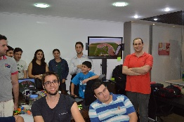Besides the educational objectives, this activity has to be fun. This is why the Instructor should act as a Gamemaster (see more at [en.wikipedia.org/wiki/Gamemaster](https://en.wikipedia.org/wiki/Gamemaster)), and provide interesting plots (see more at [en.wikipedia.org/wiki/Plot_(narrative)](https://en.wikipedia.org/wiki/Plot_(narrative))) during the Scrum Simulation. For those not familiarized with such concepts, comes from traditional Role Playing Games, or simply RPG (see more at [en.wikipedia.org/wiki/Role-playing_game](https://en.wikipedia.org/wiki/Role-playing_game)), a game in which players assume the roles of characters in a fictional setting. The Gamemaster is a person who acts as an organizer, officiant for questions regarding rules, arbitrator, and moderator within an RPG game - basically he plays as God. Besides being responsible by all NPCs (non-player characters), the Gamemaster is a storyteller and creates all events inside a story which affect other events through the principle of cause and effect.

What plots you can create? Use your imagination. Here are some suggestions that will provide a good entertainment:

* A saboteur inside a Scrum Team;
* A ghost haunting the construction because it has been built upon a cemetery (!);
* An epidemic letting some students temporarily out of the game;
* Weather changes or natural disasters inside Minecraft;
* An ambitious company wanting to promote inappropriate practices solely for profit;

It is important not to underestimate the technical aspects of Minecraft. If you have good skills with Minecraft, then you must provide coaching for the students regarding how things work or how they can perform better at the game. If you are not comfortable with Minecraft, you should ask someone else to help you as a Facilitator - try to contract a Minecraft freelancer for a great price by posting your need on online forums like [planetminecraft.com/forums](http://www.planetminecraft.com/forums/) and [minecraftforum.net/forums](http://www.minecraftforum.net/forums). Another fact is that, eventually, someone may have to provide administrative support at the server during the execution of the learning activity.

# Watch for Dysfunctions

Dysfunctions regarding the agile values, principles, roles, ceremonies and artifacts are expected. And very welcomed. They represent excellent opportunities for the Instructor to provide constructive feedback during all phases of the simulation.

## Lack of Adherence on Agile Values & Principles

The agile values and principles stated within the Agile Manifesto ([agilemanifesto.org](http://www.agilemanifesto.org/)) are difficult to comprehend if the student has worked for long period in a culture of strict hierarchy, bureaucracy and silo mentality. Cultural aspects and habits are not easy to change. During the pressure of the simulation, you may expect students to behave exactly opposite to what says the Agile Manifesto. What is perfectly normal, as long you are aware and taking advantage of the situation to provide guidance during the Game and Post-Game phases.

As part of my MSc dissertation, I invited experienced agile instructors to participate in a survey ([gameagile.com/surveys/pre-exercise-survey-for-agile-instructors](http://gameagile.com/surveys/pre-exercise-survey-for-agile-instructors/)). There was a question asking them to rank the four values of the Agile Manifesto in terms of difficulty of comprehension by students, the best placed in the ranking was:

* Responding to change over following a plan;

The same ranking was answered for the twelve principles of the agile manifesto. The three best placed in the ranking were:

* Simplicity--the art of maximizing the amount of work not done--is essential;
* The best architectures, requirements, and designs emerge from self-organizing teams;
* Agile processes promote sustainable development. The sponsors, developers, and users should be able to maintain a constant pace indefinitely;

These results are a clear picture of the paradigm conflict for students. It evidences that the mindset imposed by traditional project life cycles, based on predictive/waterfall models, remains dominant. The Scrum Simulation is a great place to fight against such mindset, as the students will feel for the first time what is to be "agile" - a great experience that can be a turning point for them.

## Scrum Dysfunctions / Scrum-But

Even with the simplicity of the Scrum Framework, it is a Herculean task to establish the necessary discipline and commitment. The roles will defy the current mindset of the students. The time box ceremonies will require a high level focus to achieve success. The constant updates of the product backlog and scrum board will stress the autonomy of the team, since there is no longer a manager to say "what to do".

In these situations, you may help the Scrum Masters in two different moments, according what you judge that will benefit more the didactic:

* In real time. Although I do recommend to let them fail at least once, after this you may discreetly give an advice.
* During the post-game debrief. You can save or reinforce your advices at the debrief, just to keep everyone on the same page.

# Game Phases

## Minecraft Bootcamp (2 hours)

The Minecraft Bootcamp is where most of students will have the first contact with Minecraft. You will have to present the game to them, telling the history behind the game, how it works and showing several examples of great constructions. The idea is to raise awareness regarding the true potential of Minecraft, I do suggest you to search for some videos on YouTube. After that, it is hands-on time.

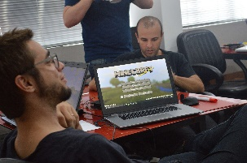If the training center has no computers, you will have to make them install the game on their own notebooks. In this case, tell them to bring also a mouse... it is critical for Minecraft. The installation will take at least 30-60 minutes, supposing that there is a good internet connection and just minor problems will show up. Use USB pen drives to distribute the installation file, this will speed up things. Be sure to standardize the versions of Minecraft configured in the student’s notebooks, it should be equal to the version of the Minecraft Server. For more info about client versions, visit [howtogeek.com/203196/how-to-change-your-minecraft-game-version-and-set-up-profiles/](http://www.howtogeek.com/203196/how-to-change-your-minecraft-game-version-and-set-up-profiles/). Minecraft depends on JRE (Java Runtime Environment), some students will have to install it by visiting [java.com/en](https://www.java.com/en/).

With Minecraft installed, the next move is to make the students join the Minecraft Server and teach the basic controls & commands. Here is a good walkthrough to teach how to join a server [minecraft.gamepedia.com/Tutorials/Playing_on_servers](http://minecraft.gamepedia.com/Tutorials/Playing_on_servers). There is also a good explanation about the controls at [minecraft.gamepedia.com/Controls](http://minecraft.gamepedia.com/Controls).

You may leave students playing Minecraft for a while, until the completion of the estimated two hours for the Minecraft Bootcamp. In this way they will become more familiar with the interface and comfortable to start the simulation.

## Pre-Game (1 hour)

The objective of the Pre-Game phase is to prepare everything for the start of the first Sprint (Game phase). The templates of all Scrum Artifacts used within this simulation (Product Backlog Board, Scrum Board and Release Burndown Chart) are available to download at [gameagile.com/scrum-simulation-with-minecraft](http://gameagile.com/scrum-simulation-with-minecraft/). You may choose to print/adapt them before the simulation or ask the students to write them on cardstock sheets during the Pre-Game phase.

The next subsections represent a stepwise approach to put everything in order:

### Product Backlog Board

You will use basic product backlog board, where the stories will be grouped by priority. It is enough to guarantee a good visibility and easy organization. Use the template below:

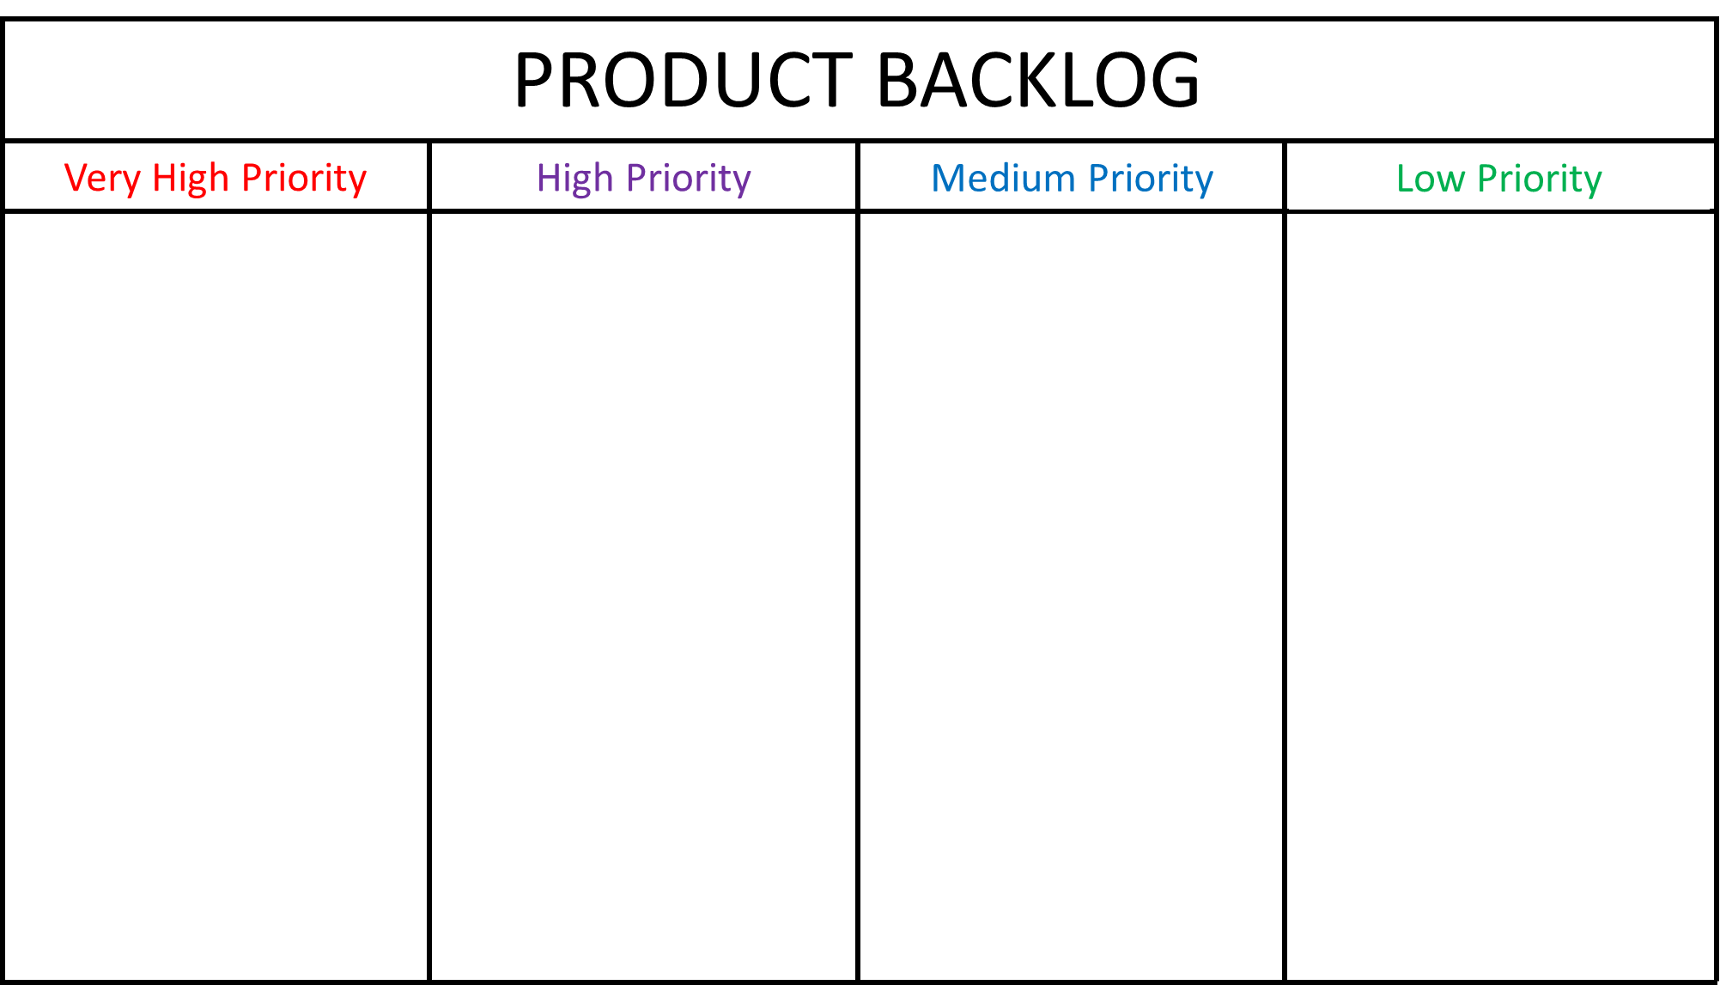

There are different colors for the column titles (priorities), later you will use those colors to tag the stories.

### User Stories

The user stories will be written on post-it, so let’s keep it simple. I do recommend the formula: “As a <user>, I want <goal> so that <reason>”. To save time, the Product Owner shall create a list all stories before the simulation, as mentioned in the "Roles" section.

Ask the help of students to write all stories on post-its. Remember to let some space at the header of each post-it, in the future we will use this space to mark the priority and size estimation. The stories will look like:

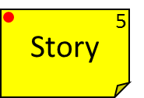

### Estimation and Prioritization of the User Stories

I use a very fast variation of the planning poker, respecting the scale 0, 1, 2, 3, 5, 8, 13, 20, 40 and 100. The procedure to perform this variation of the Planning Poker is:

1. The Product Owner must read one story in a loud voice;
2. The students have 60 seconds to ask any questions to the Product Owner, further questions can be answered during the Sprint Planning. They should write any important details in the back of the post-it;
3. The Scrum Teams have more 60 seconds to search for an inner consensus regarding the size estimation;
4. The Scrum Teams have more 60 seconds to search for overall consensus regarding the size estimation;
5. The Product Owner have to write the size estimate in the upper right corner of the post-it;
6. The Product Owner have to put a color mark in upper right corner of the post-it, regarding the priority;
7. The Product Owner have to place the story in the correct quadrant of the Product Backlog Board;

Before start the estimative, you must instruct the Scrum Masters to facilitate the consensus as the teams will have little time to perform it. Don´t forget to tell them that they are responsible to control the time limits and maintain a productive rhythm.

Use the template below:

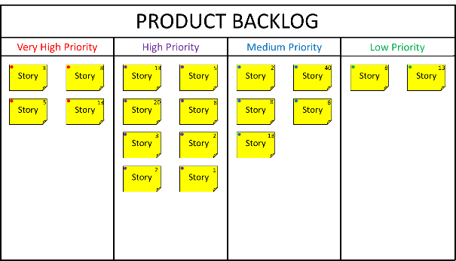

### Scrum Boards

Each Scrum Team must have its own Scrum Board, which follows a very basic template. The Scrum Board will be reused in every Sprint, just remember the teams to inform the current sprint in the header of the board. The tasks will be defined and estimated by the Scrum Teams during each Sprint Planning. Use the template below:

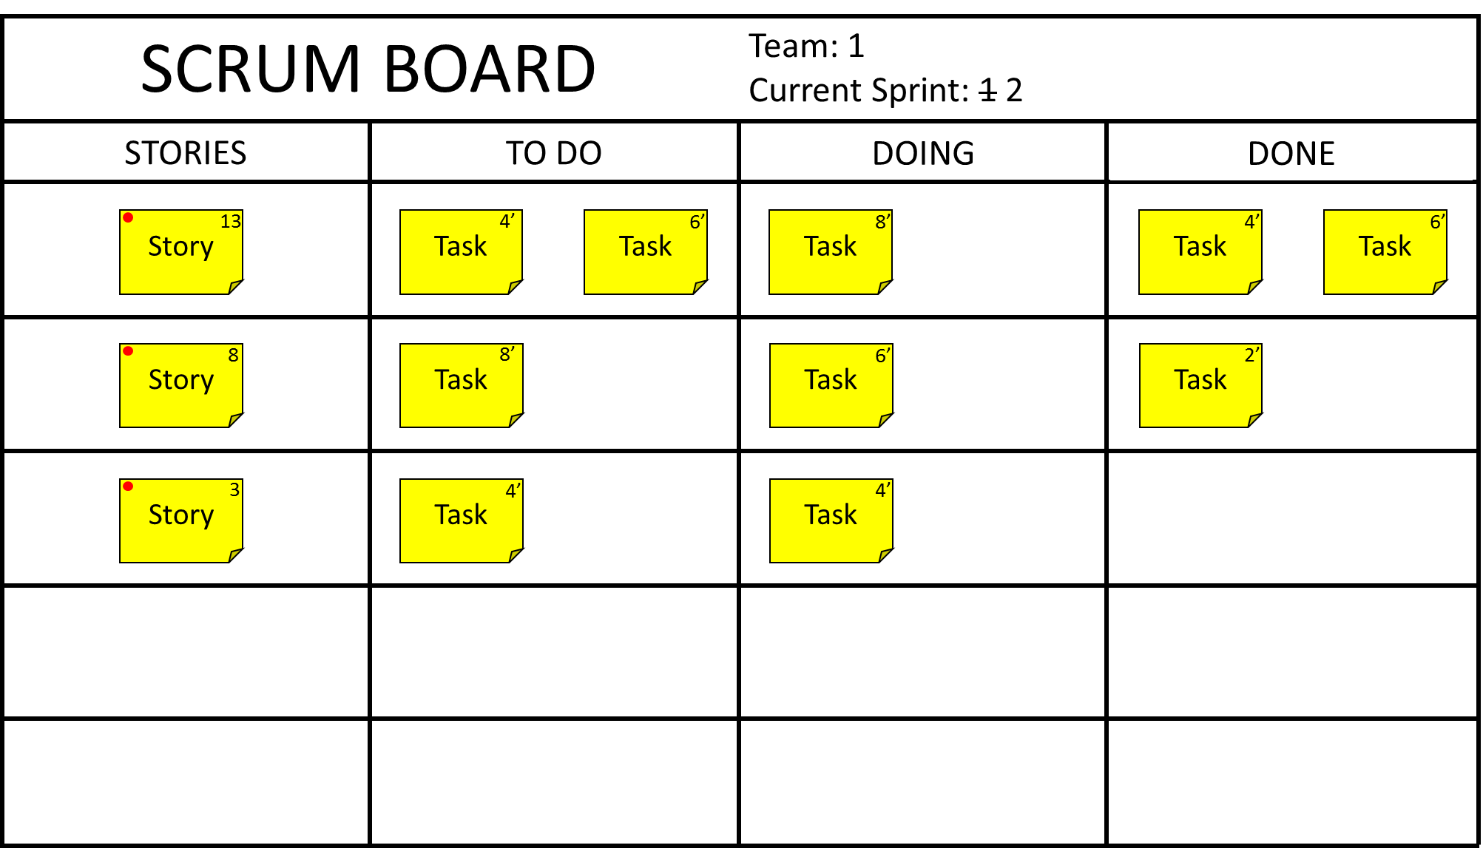

### Release Burndown Charts

Each Scrum Team will have his own Release Burndown Chart. An integrated Release Burndown Chart, containing the result of all Scrum Teams, will also be used. The templates of the Release Burndown Charts will have the Story Points scale in blank, in this way the Scrum Masters will be capable to adapt it according to the size of the Product Backlog.

Use the template below for the Release Burndown Chart for each Scrum Team:

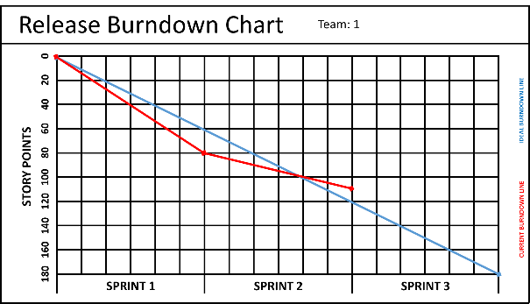

Use the template below for the Integrated Release Burndown Chart:

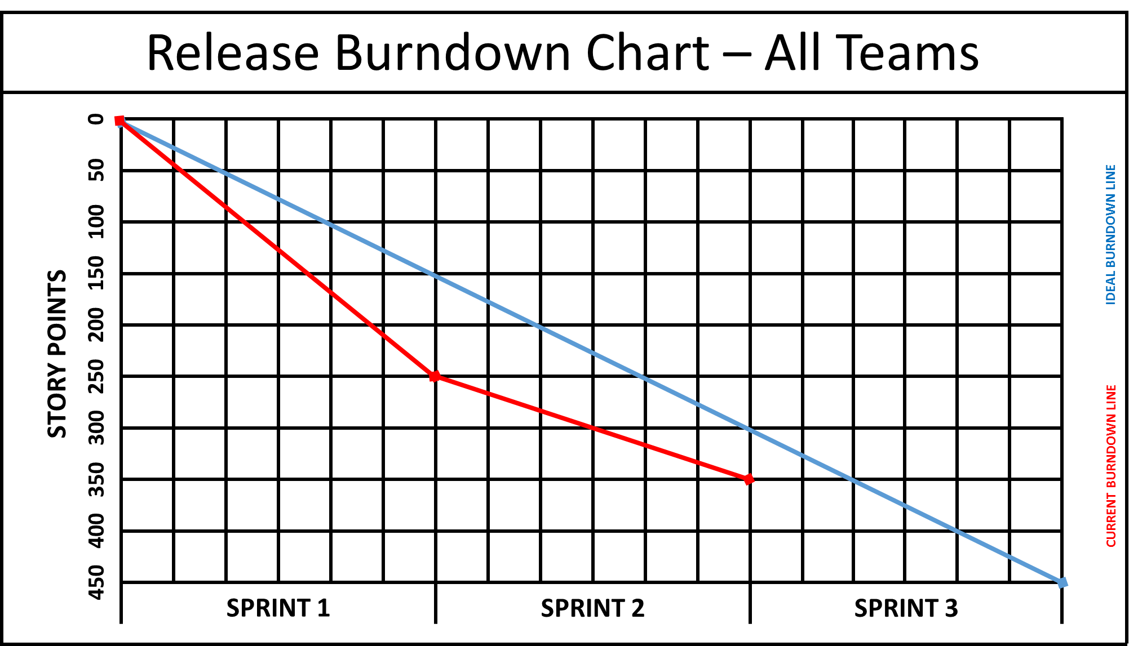

Ask the teams to place all boards in the walls, don't forget to think in the logistics and visibility.

## Game (4 hours)

This Game Phase will contain 3 full sprints of 80 minutes each one, totalizing 4 hours of execution. The Scrum Masters, as guardians of Scrum, are supposed to know the basic rules of each ceremony. They also must be alert and helping to solve all blocks.

Each Sprint will follow all ceremonies of Scrum, respecting the defined time boxes for each one.

### Sprint Planning (20 Minutes)

For the simulation purpose, the Sprint Planning is divided in two parts.

The first part takes 10 minutes and is the negotiation of the backlog with the Product Owner, including the clarification of questions and any need for estimates review. I also recommend to define the sprint goal, one or two short sentences containing the description of what is planned to be achieved during the sprint.

The second part takes more 10 minutes and is where the teams will break down each story in one or more tasks, providing an estimate in minutes.

### Sprinting (45 Minutes)

The Sprinting is the time when the Scrum Teams will build inside Minecraft. As this is a complete simulation of Scrum, there will be two Daily Scrums - each lasting up to 3 minutes:

* The first will happen 15 minutes after the beginning of the execution;
* Se second will happen 30 minutes after the beginning of the execution;

You may run a Sprint 0/Spike with half the time of a regular sprint, to mitigate any technical/knowledge risks. This will increase the duration of the simulation, but may produce benefic effects.

The Scrum Teams, before the ending of the Sprinting, may agree on how they will present the results within Minecraft at the Sprint Review. Otherwise this will be an improvement point to be addressed inside the Sprint Retrospective.

### Sprint Review (10 Minutes)

Time to show the results of the sprint to the Product Owner. As the Product Owner will be "inexperienced", there will be certain conflicts.

Exists a great chance of failure in the first sprint. Perfectly normal as they are very immature in the Scrum Framework, not to say on Minecraft. May serve as material for the Sprint Retrospective and motivational boost for the next sprints.

### Sprint Retrospective (5 Minutes)

Each Scrum Team must hold their own Retrospective, aiming to best their overall performance and look for improvements in the process. The instructor must use this meeting to give small pills of experience and help the teams to see opportunities of improvement.

## Post-Game (1 hour)

The Post-Game phase represents the debriefing and is the most expected moment by the instructor. I invite all students to sit in a circle, and tease an open discussion regarding the experiences and learning points. Common questions to be raised:

* How was the experience?
* From an educational point of view, it was positive?
* It was fun?
* Regarding the simulation, what were the coolest things?
* Regarding the simulation, what were the things that could be improved?
* The situations that you have experienced are like the real world?
* Regarding the Scrum Framework, what do you think you performed well?
* Regarding the Scrum Framework, what do you think you could improve?
* Did you enjoy Minecraft?

Remember to give your personal contributions as Instructor, based on your observations during the simulation and experience with agile.

# Learning Points

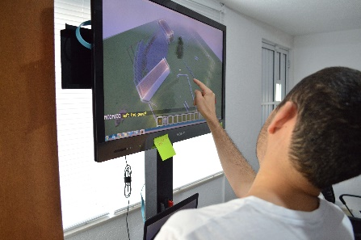The values and roles of Scrum represent a big paradigm shift for professionals whom are familiar with traditional approaches for project management, where command-and-control-ism and micro-management are imperatives. This learning activity provide to the students a great opportunity to experience the Scrum framework, with several elements of a real-world project.

In my agile classes, the Scrum simulation is the last mile of the training - the "cherry on the cake". This is where the students evolve their own comprehension, seeing how all the pieces fit together: values, principles, roles, ceremonies and artifacts.

# Inspirations

I've listed below the most relevant agile simulations, and which have influenced this learning activity:

* Scrum Simulation With Lego - <http://www.lego4scrum.com/>
* Resort Brochure Scrum Mini-Simulation - <http://tastycupcakes.org/2009/06/resort-brochure/>
* XP Game - <http://www.xp.be/xpgame/>
* Ball Point Game - <https://kanemar.files.wordpress.com/2008/03/theballpointgame.pdf>
* Agile Airplane Game - <http://gistlabs.com/2011/06/agile-airplane-game/>

# About

My name is Julio Oliveira, I’m from Sao Paulo / Brazil. I’m married with an incredible woman called Francine and I have two lovely children: Sarah (8 years old) and Nicolas (2 years old). I’m a technology savvy, who loves games, geek stuff and hi-tech. Also I adore the Japanese culture in general, including aikido, shogi, manga, sushi…

As a professional, I’m a IT Project Manager and entrepreneur who worked at large multinational organizations such as Volkswagen and Rede Globo, being responsible for budgets in excess of US$6 Million. My specialties are software engineering, agile project management and service oriented architecture.

Graduated in Computer Networks Management, post graduated in Software Processes Management, MBA in Project Management, currently enrolled at the master degree program (MSc) in Information Systems Management at the University of Liverpool (UK). Holder of the credentials PMP and PMI-ACP of the Project Management Institute (PMI).

This learning activity is a product of the dissertation from my master degree (MSc) in Information Systems Management at the University of Liverpool (UK), with the title: “The effectiveness of gamification as a problem-based learning tool on teaching agile project management”.

E-mail Address: [julio.oliveira@online.liverpool.ac.uk](mailto:julio.oliveira@online.liverpool.ac.uk)

Linkedin Profile: <https://www.linkedin.com/in/juliooliveira>

Website: <http://gameagile.com/>